Medium Article: Title TBD
SUMMARY (TLDR)

Body
DATA & TOOLS
I acquired this dataset from Kaggle[1], in a CSV format. The data was sourced from SoFIFA, dated in 2020. The dataset was specifically chosen as it was a messy variation of the data. Other samples had been cleaned prior.
The data has over 18k rows and 77 Columns.
The tools used: Excel, Power BI
I decided to clean the data using Excel, due to the fact that it was only one table’s worth of data, which did not require complex methods or functions for grouping or cleaning. Power BI was used for visualizations, as it allows me to publish the dashboard and embed it into websites for interactive usage on the free tier.

METHODS
The method I use and have learnt for analysing data follows a similar methodology in almost every instance.
- Understand the context behind the data and the data itself.
- Clean the data
  - Remove duplicates of data
  - Standardize the data
- Visualize the data for business purposes
Having understood the context behind the data from the Kaggle page, I immediately got into cleaning the data.

Removing duplicates
Luckily the data has unique ID values for each player, so that could be used to verify that the data does not have any duplicates.
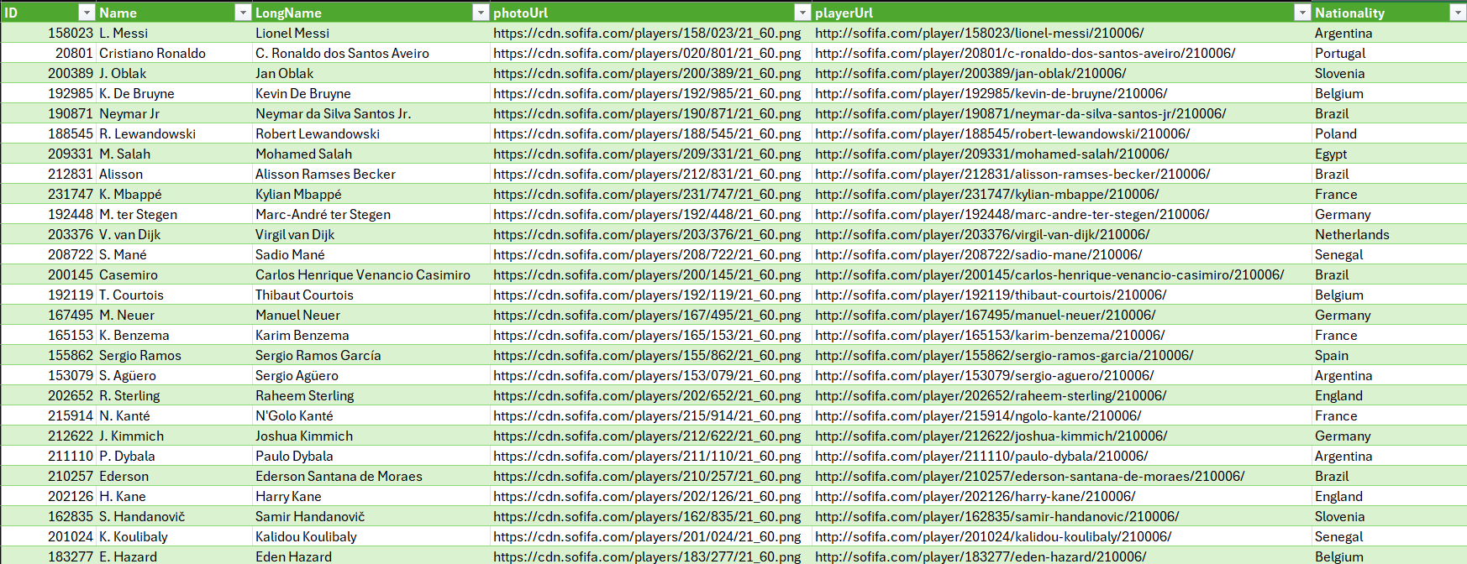

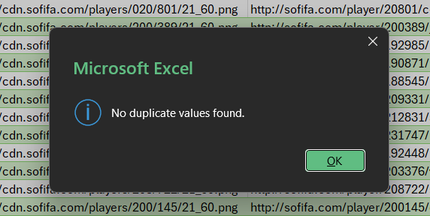

Standardizing the data
Here is where a lot of the work resides in cleaning the data.
- Removing whitespaces
I started by using the TRIM function on every column to eliminate any hidden whitespaces in:
- names of players, clubs, countries, etc.
- Values of stats

- Standardizing units of measurement and currency.
The dataset had stored values such as height and weight in both metric and imperial measurement standards.
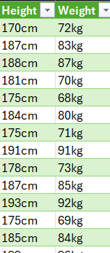
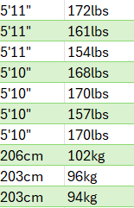

Alongside this, the values, wages of players and other money-based columns had mixed characters into the actual values (Such as “K” representing Thousands and “M” representing millions). The currency was measured in euros across all rows.
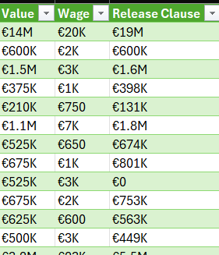

Since I reside in a country using the metric system, I decided to convert these values to follow the system’s units.
Starting with the weight, I used the following functions which removed the units of measurement and converted pounds (lbs) to kilograms (kg):
- =IF(IFERROR(SEARCH("lbs"; [row]); 0) <> 0; ROUND(TRIM(SUBSTITUTE([row]; "lbs"; "")) / 2,205;0); [row])
- =TRIM(SUBSTITUTE([column]; "kgs"; ""))
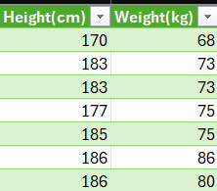
For height I, I used a SWITCH and TRIM function to convert It into cm.
- =SWITCH()
- =TRIM(SUBSTITUTE([row]; "cm"; ""))

For the currency, I used a very large IF formula with nested IFERROR functions inside to remove the currency symbol and to multiply the values by the appropriate value (either 1,000 or 1,000,000).
- =IF(IFERROR(SEARCH("M"; [column]); 0) <> 0; TRIM(SUBSTITUTE(SUBSTITUTE([row];"€";""); "M"; ""))*1000000;
IF(IFERROR(SEARCH("K"; [row]); 0) <> 0; TRIM(SUBSTITUTE(SUBSTITUTE([row];"€";""); "K"; ""))*1000; TRIM(SUBSTITUTE([row];"€";""))*1))
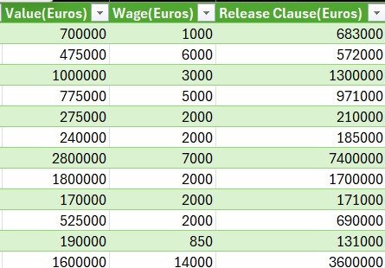

There were also other columns which had special characters (like a star symbol) which I removed using a simple combination of a SUBSTITUTION and TRIM formula.
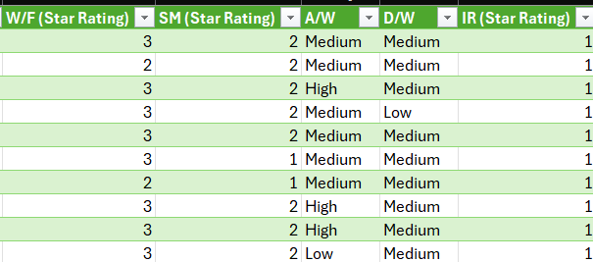
- =TRIM(SUBSTITUTE(SUBSTITUTE([row];" ★";"")
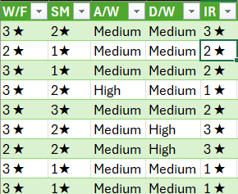

- Dealing with data and logical inconsistencies
The dataset had a column called “Contract” with mixed values. Some rows had a range with values representing years which contracts start and when they end. Other rows had a contract end date, in a different date format, as well as a descriptor of the contract type (“On Loan”). Another kind of value popping up was the word “Free” in the column as well, signalling that a player was a free agent who belonged to no club.
To deal with this, I added an extra column for Player Status - this column has values indicating the contract type (“Permanent”, “On Loan”, “Free”). I also split the contract start dates and end dates.
- =IF(IFERROR(SEARCH("On Loan"; [row]); 0) <> 0; "On Loan"; IF(IFERROR(SEARCH("Free"; [row]); 0) <> 0; "Free"; "Permanent"))
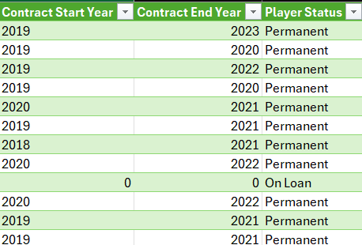
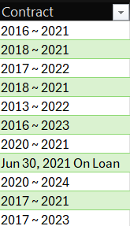

Another issue I saw in the dataset was that loan dates only had an end date, with a column named “Joined” with a date. I assumed that the date in the “Joined” column was more so related to something with the data and the website. With this assumption, I changed those values to 0, as to not create any issues with data types.
- =IF(LEN(TRIM([row)) <> 4; 0; [row])
The final touch-ups had to do with special characters not recognised by Excel and correcting them.

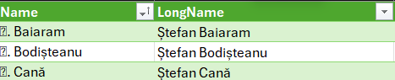

ANALYSIS
& VISUALIZATIONS

